Epsom & Ewell
7
v
Dorking Wanderers Reserves
Saturday, 23rd November 2019 – 3.00 p.m.
Good afternoon and welcome to High Road for our latest Combined Counties League match against Dorking Wanderers Reserves. We welcome their players, supporters and the match officials and hope they have a safe journey home.

We are of course meeting up with a few former Salts today. Their Manager, Carl Downs is no stranger as he made 113 appearances for us and was also a member of our League Cup winning side in 2013. Carl is still only 26 and I recall telling him a few years ago that he was too young to go into Management as he still had so much to give as a player! I also notice that his younger brother Jake is in the squad line up. He also played for us five times before suffering a nasty injury that kept him out for a while. It’s good to see him playing again. Also, former player Ben Dyson and former Assistant Manager Jordan Clark return, although of course both were involved in our contests last season. Ben made 42 appearances for us in a number of positions.

We met twice last season; the first match being back in September of 2018 where we led 2-1 at the half but collapsed to a 5-3 defeat. Our revenge came almost a year ago to the day when on 27th November of last year we defeated them 3-0 here at High Road.

We were last here back on Saturday 19th October when we defeated FC Deportivo Galicia by three clear goals to register our first clean sheet of the calendar year. We then visited Raynes Park for a match with Kensington and Ealing Borough who defeated us 3-1 and followed this with a trip to Walton & Hersham, who outplayed us 6-3. One of our goals in that match came from Marlon Pinder who has rejoined us, while we have another new signing in Jahmahl King who has played in our recent away matches. Further additions have also joined in James Fray, Tariq Straker and George Smith, while returning to the club are Steve Betancourt and Conor Young. Welcome to all players.

We were due to host Sandhurst Town but this match was delayed due to a County Cup tie for our Berkshire opponents, so we had a ten day break before visiting Tooting Bec on Tuesday 12th November where we were narrowly edged out 2-1 by a late goal. Then last Saturday we took the flight to Jersey where we faced the Jersey Bulls at Springfield Stadium and lost a competitive match 2-0. An article on our trip will appear in the Bedfont & Feltham programme on 14th December. We were due to follow this with a local derby at Chessington & Hook United on Tuesday, but the match was called off on Tuesday afternoon, even though we had 48 hours with no rain to that point!

We now host Sandhurst Town this coming Tuesday in a rearranged League match, so come on over! We also now know the date for our match at Sutton United Development in the First Round of the Surrey Premier Cup. It will be played on Monday 9th December at Gander Green Lane.

Enjoy the game!

Rich

You can follow us on social media – just see the inside cover for details.

Cover photo by Gemma Jarman

Scott Murphy puts us ahead at Kensington & Ealing Borough with a
near post header in our 3-1 defeat on 26th October 2019

Cherry Red Records Combined Counties League
Division One Table 2019/20
incl Saturday 16th November | P | W | D | L | F | A | Pts | GD | H | A

Jersey Bulls | 15 | 15 | 0 | 0 | 57 | 5 | 45 | +52 | 13/4 | 0-2
Farnham Town | 12 | 9 | 2 | 1 | 28 | 10 | 29 | +18 | 0-2 | 15/2
Tooting Bec | 13 | 8 | 4 | 1 | 35 | 17 | 28 | +18 | 2-2 | 1-2
Walton & Hersham | 14 | 8 | 2 | 4 | 40 | 24 | 26 | +16 | 31/3 | 3-6
Kensington & Ealing Boro | 14 | 8 | 0 | 6 | 34 | 29 | 24 | +5 | 21/1 | 1-3
Sandhurst Town | 13 | 6 | 4 | 3 | 25 | 19 | 22 | +6 | 26/11 | 14/3
Westside | 13 | 6 | 2 | 5 | 29 | 20 | 20 | +9 | 28/12 | 3-1
AFC Hayes | 13 | 6 | 2 | 5 | 34 | 27 | 20 | +7 | 1-4 | 18/1
Dorking Wanderers Res | 16 | 6 | 2 | 8 | 34 | 39 | 20 | -5 | 23/11 | 11/4
British Airways | 15 | 5 | 4 | 6 | 26 | 36 | 19 | -10 | 11/1 | 29/2
FC Deportivo Galicia | 16 | 5 | 4 | 7 | 20 | 38 | 19 | -18 | 3-0 | 1/2
Bedfont & Feltham | 13 | 5 | 2 | 6 | 26 | 25 | 17 | +1 | 14/12 | 18/4
Cove | 13 | 4 | 4 | 5 | 24 | 36 | 16 | -12 | 25/1 | 2-2
Fleet Spurs | 14 | 5 | 0 | 9 | 26 | 32 | 15 | -6 | 3-5 | 7/12
Epsom and Ewell | 14 | 4 | 2 | 8 | 27 | 34 | 14 | -7 | x | x
Ash United | 14 | 4 | 0 | 10 | 23 | 40 | 12 | -17 | 8/2 | 2-1
Chessington & Hook Utd | 12 | 3 | 5 | 4 | 20 | 23 | 11* | -3 | 22/2 | 19/11
Bagshot | 13 | 3 | 2 | 8 | 16 | 32 | 11 | -16 | 4/4 | 1-2
Godalming Town | 12 | 3 | 1 | 8 | 22 | 37 | 10 | -15 | 5-2 | 30/11
Eversley & California | 13 | 1 | 2 | 10 | 11 | 34 | 5 | -23 | 21/3 | 21/12
* Chessington & Hook United – 3 points deducted for playing an ineligible player on 3rd August v Godalming Town

Lucky Day? – 23rd November
Played 9 - Won 2 Drawn 3 Lost 4 - For 14 Against 19 - PPG 1.00 - Poor
Our Club record against Dorking Wanderers Reserves
Played 2 - Won 1 Drawn 0 Lost 1 - For 6 Against 5 - PPG 1.50 - Average
Our Largest wins and losses against Dorking Wanderers Reserves
Tuesday, 27th November 2018 - W 3-0 - Combined Counties League (H)
Tuesday, 11th September 2018 - L 3-5 - Combined Counties League (A)
Dorking Wanderers Reserves Last Visit
Tuesday, 27th November 2018 - Won 3-0 - Combined Counties League

Latest Results and Fixtures
Combined Counties League – Saturday 19th October
Bagshot | 2-3 | British Airways
Bedfont & Feltham | 2-3 | Kensington & Ealing Borough
Cove | 3-1 | Eversley & California
Epsom & Ewell | 3-0 | FC Deportivo Galicia
Fleet Spurs | 1-3 | Farnham Town
Godalming Town | 4-2 | Ash United
Jersey Bulls | 1-0 | Walton & Hersham
Sandhurst Town | 1-2 | Dorking Wanderers Reserves
Tooting Bec | 2-2 | Chessington & Hook United
Westside | 2-0 | AFC Hayes
Esoteric Division One Cup – Second Round – Tuesday 22nd October
British Airways | 0-3 | Bedfont & Feltham
Cove | 1-1 - pens-2-4 | FC Deportivo Galicia
Dorking Wanderers Reserves | 2-3 | Jersey Bulls
Godalming Town | 5-2 | Farnham Town
Sandhurst Town | 4-1 | Chessington & Hook United
Combined Counties League – Saturday 26th October
AFC Hayes | 3-1 | Godalming Town
Ash United | 2-1 | Fleet Spurs
British Airways | 0-6 | Walton & Hersham
Chessington & Hook United | p-p | Jersey Bulls
Cove | 3-3 | Westside
Dorking Wanderers Reserves | 0-4 | Tooting Bec
Eversley & California | 0-5 | Bedfont & Feltham
Farnham Town | 1-1 | FC Deportivo Galicia
Kensington & Ealing Borough | 3-1 | Epsom & Ewell
Sandhurst Town | 2-2 | Bagshot
Combined Counties League – Tuesday 29th October
AFC Hayes | 1-5 | Fleet Spurs
Buildbase F.A. Vase – Second Round – Saturday 2nd November
Welling Town | 3-1+ | Bedfont & Feltham
Combined Counties League – Saturday 2nd November
AFC Hayes | p-p | British Airways
Bagshot | 2-1 | Tooting Bec
Farnham Town | 3-1 | Ash United
FC Deportivo Galicia | 1-1 | Eversley & California
Latest Results and Fixtures
Combined Counties League – Saturday 2nd November
Jersey Bulls | 5-0 | Dorking Wanderers Reserves
Kensington & Ealing Borough | p-p | Chessington & Hook United
Sandhurst Town | p-p | Fleet Spurs
Walton & Hersham | 6-3 | Epsom & Ewell
Westside | p-p | Godalming Town
Combined Counties League – Saturday 9th November
Ash United | 1-4 | Walton & Hersham
Bedfont & Feltham | 0-3 | Jersey Bulls
Chessington & Hook United | 2-4 | FC Deportivo Galicia
Cove | p-p | Bagshot
Dorking Wanderers Reserves | 2-5 | AFC Hayes
Eversley & California | p-p | Farnham Town
Fleet Spurs | 2-1 | Westside
Godalming Town | 2-1 | British Airways
Tooting Bec | 3-1 | Kensington & Ealing Borough
Combined Counties League Cup 2nd Round – Tuesday 12th November
Bedfont & Feltham | 1-5 | Knaphill
Camberley Town | p-p | Colliers Wood United
CB Hounslow United | p-p | Balham
Hanworth Villa | 2-3 | Jersey Bulls
Combined Counties League – Tuesday 12th November
Chessington & Hook United | p-p | Ash United
Tooting Bec | 2-1 | Epsom & Ewell
Walton & Hersham | 2-2 | Sandhurst Town
Combined Counties League Cup 1st Round – Wednesday 13th November
FC Deportivo Galicia | 2-9 | AFC Hayes
Combined Counties League – Saturday 16th November
AFC Hayes | 3-0 | Eversley & California
Bagshot | p-p | Farnham Town
British Airways | 3-3 | Chessington & Hook United
Dorking Wanderers Reserves | 1-1 | Cove
FC Deportivo Galicia | 4-1 | Fleet Spurs
Jersey Bulls | 2-0 | Epsom & Ewell
Kensington & Ealing Borough | p-p | Godalming Town
Walton & Hersham | 3-4 | Bedfont & Feltham
Westside | p-p | Tooting Bec
Latest Results and Fixtures
Combined Counties League Cup 2nd Round – Tuesday 19th November
Abbey Rangers | V | Raynes Park Vale
Esoteric Division One Cup 2nd Round – Tuesday 19th November
Walton & Hersham | V | AFC Hayes
Combined Counties League – Tuesday 19th November
Ash United | V | Westside
Chessington & Hook Utd | p-p | Epsom & Ewell
Eversley & California | V | Godalming Town
Combined Counties League – Saturday 23rd November
Bagshot | V | Walton & Hersham
Bedfont & Feltham | V | Godalming Town
Epsom & Ewell | V | Dorking Wanderers Res
Eversley & California | V | Chessington & Hook United
Farnham Town | V | AFC Hayes
Fleet Spurs | V | British Airways
Jersey Bulls | V | Cove
Kensington & Ealing Borough | V | FC Deportivo Galicia
Tooting Bec | V | Ash United
Westside | V | Sandhurst Town
Combined Counties League – Tuesday 26th November
AFC Hayes | V | British Airways
Epsom & Ewell | V | Sandhurst Town
Combined Counties League – Wednesday 27th November
Westside | V | Godalming Town
Combined Counties League – Saturday 30th November
AFC Hayes | V | Westside
Ash United | V | Kensington & Ealing Borough
British Airways | V | Dorking Wanderers Reserves
Chessington & Hook United | V | Walton & Hersham
Cove | V | Tooting Bec
Eversley & California | V | Fleet Spurs
FC Deportivo Galicia | V | Bagshot
Godalming Town | V | Epsom & Ewell
Jersey Bulls | V | Farnham Town
Sandhurst Town | V | Bedfont & Feltham

From behind the goal
Epsom & Ewell 3-0 FC Deportivo Galicia
Combined Counties League Division One - Saturday 19th October 2019

Three goals, three points and a clean sheet!

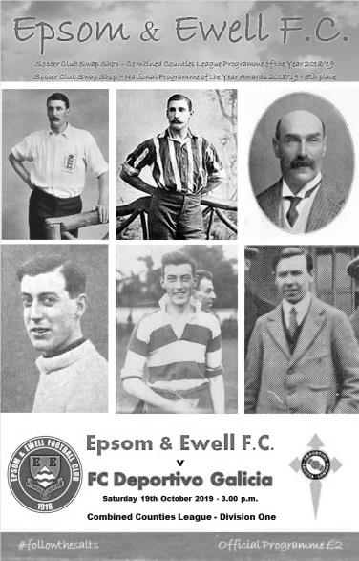
Back on 29th December 2018 we defeated Eversley & California by a single goal to see out the old year. Nearly ten months and 33 matches later I am able to report on our next one, registered comfortably enough against an FC Deportivo Galicia team that were fairly limited, but hung around for far too long before we finally killed off their hopes with a pair of late goals.

The first question people will ask is whether there was any change in our defence this week and there were a few. Firstly, Chaz-Lee Martin returned to the heart of the defence after missing a number of games through a combination of an extremely harsh suspension and illness, while on the left Kyle Carton came in for Joe Bonass-Ward who was on the bench. Todd Murphy remained alongside Martin with Lloyd Connelly on the right. Behind them new goalkeeper Ricardo Teixeira made his debut in place of Felix Davies and this was really unfortunate timing for our previous keeper, as after ten matches for us this season where he was frequently exposed by his defence, the new man did not have a save of consequence to make!

In midfield Adam Heagney failed a late fitness test so Sean White, Scott Murphy and Jake Robinson filled the midfield berths, leaving Bobby Bennett and Jordan Gallagher on the flanks supporting Taryn Smith. Bennett in particular had an excellent game while Gallagher had a really good battle with the visiting Ahmed El Hanna until both were replaced towards the end of the match.

It was a pity that only 29 spectators were present to watch a particularly good start from our boys this week as the opposition rarely got out of their half for the opening half hour. We took the lead in the 13th minute when Robinson fed Gallagher on the left wing and he cut back, delivering a right footed teasing cross that was met by a slight touch eight yards out from Murphy that gave Dani Diaz no chance. It was a fine run to reach the ball from our Captain and I'm sure he would be pleased to hear it described as "Lampard-like"!

The pressure continued but the second goal wouldn't come. White hit a far post volley sweetly enough and it was only a couple of feet the wrong side of the post; nestling in the side netting before a deep White corner was headed back at goal by Martin and although a defender was there to partially hook it clear, Murphy was first to reach the loose ball, heading it just over the bar from close range. Robinson then had a couple of efforts on goal, the first of which required a routine save, while the second looped just over the crossbar.

Then on the half hour two defenders went for the same ball which fell kindly for Bennett who arrowed in but saw his low strike blocked by the legs of Diaz.

The opposition's first attempt on goal came in the 39th minute but it was low and wide and Teixeira watched it go out for a goal kick. Maybe the opposition were frustrated but their attempts to trick the referee just before half time after Scott Murphy had cleared the ball and then caught a player as he followed through were a bit unnecessary. A quick discussion with the Assistant convinced the referee that nothing untoward had occurred and their bench sat back down. Having said that, there were a number of decisions that were questionable throughout the match and we also had a debatable shout for a penalty when Gallagher's cross hit the arm of a defender. It looked like ball to hand, but the hand was definitely a long way from the body and the penalty could easily have been awarded.

A second goal might well have made the afternoon a little more comfortable for the supporters, but we'd have to wait as the second half became a nervy affair at times as the play degenerated. White received a yellow card for a foul, although he appeared to have been fouled first, and Martin sent a Gallagher corner just over the bar with his now trademark powerful header.

But overall, there was little to write home about as the game became quite niggly, not helped by an official who appeared to be lacking in presence. With the memory of so many leads having been given up recently, there was real concern that just one mistake could give them an equaliser, but we remained in control and finally in the 86th minute we clinched the points, although the goal carried an element of fortune with it. Smith had made a good run as he latched on to a midfield pass. He cut onto his right and attracted a second defender so probably should have passed at this point to the completely unmarked Bennett. However, he shot at goal anyway and the ball struck a defender and looped up over Diaz and into the net from 20 yards.

This may have been slightly fortunate but it was the very least we deserved and Bennett made the scoreline a fair one by scoring a third goal three minutes later as we broke away and he rounded the keeper and sent the ball flying into the net to register the goal his performance had deserved. It was nearly four as Bennett turned provider in injury time, but Smith waiting at the far post scuffed his shot from just six yards and Diaz was able to get down and make the save.

This was a much better display than in recent weeks. In addition to getting the well-publicised "clean sheet monkey" off our backs; which incidentally was the fourth longest run in club history and had not been beaten in length since 1967, we were also back to winning ways after losing four and drawing the other of our last five matches. There is still a long way to go here and there remains much room for improvement as it must be remembered that we are only tenth in the league and against a better team (of whom there are quite a few in this division) we might well have failed to see this match out, but we did look more solid and rarely looked in any danger. If I am able to write that after next week's match at Kensington & Ealing Borough, then that will be a much more impressive statement.

Epsom and Ewell; Ricardo Teixeira, Lloyd Connelly, Kyle Carton, Sean White,
Todd Murphy, Chaz-Lee Martin, Bobby Bennett, Scott Murphy(c), Taryn Smith,
Jake Robinson, Jordan Gallagher

Sub: Liam Roberts for Gallagher (75)

From behind the goal
Kensington & Ealing Borough 3-1 Epsom & Ewell
Combined Counties League Division One - Saturday 26th October 2019

Salts let another lead slip
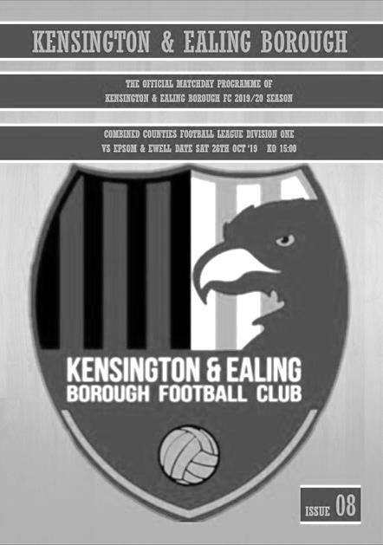
As we completed our eleventh league match of the season at Raynes Park Vale against Kensington & Ealing Borough, it was worth noting that we have been ahead in eight of these matches, yet on seven of those occasions a team has come back at us and equalised. Sometimes we have still gone on to win, but not often enough and on this occasion our opponents took the points with a pair of second half strikes.

Despite the weather and the soft conditions, both teams really went for it and produced a game that the neutral will probably have enjoyed. We started with three at the back, incorporating our new signing from South Park, Jahmahl King and we started brightly in the opening few minutes, although the first time Kensington attacked us, we conceded a penalty when their striker was brought down by Todd Murphy. It looked harsh from where I was, but I was a long way away and there were fewer protests that I expected. As it turned out though our new keeper Ricardo Teixeira then saved the penalty and the loose ball was cleared!

Having had a very quiet debut, Ricardo was always likely to be busier here against a team placed third in the league table and playing with confidence and he was down well to make a low save a minute later with the follow up being knocked into the net, but fortunately we were reprieved by an offside flag.

We had shown up well too though and in the ninth minute a wayward defensive header put Bobby Bennett through on the left. He pulled the ball back for Taryn Smith who took a touch before shooting against the keeper's right hand post and Bennett blazed the rebound over the bar. He was at a narrow angle, but really should have hit the target. Seven minutes later he had another opportunity as Lloyd Connelly produced a superb deep cross from the right but as Bennett struck at goal, he just hit the ball on the up and it also cleared the bar.

We conceded a free kick on the edge of the area in the 25th minute; one of a number we would give away in this match, but Ricardo made a comfortable save this time and we went ahead six minutes later when an Adam Heagney corner to the near post was met by the head of Scott Murphy who found the top corner, with a solid header. Regrettably we couldn't hold on for very long and in the 35th minute a clever pass behind Connelly enabled Jamarl Joseph to drill the ball past Ricardo into the bottom corner from just inside the penalty area.

In response Sean White connected really well from around 25 yards with his shot clearing the bar by only a foot. It would have been a super goal had it been a little lower and we also nearly took the lead in injury time after good work from Smith and Bennett but the shot was blocked and cleared.

Going down the hill in the second half we made an early change as Rob Hendry came of for Todd Murphy and we reverted to four at the back. It nearly paid instant dividends as a Smith ball in from the left was retrieved by Bennett and he set up White whose shot was really well blocked by the home keeper from a few yards out. Back came Kensington as the play swung from end to end and a low shot was fumbled but then cleared by Ricardo. However, in the 59th minute we went behind in unfortunate circumstances. It was a good move down the left, followed by a pull back into a dangerous area where Omar El Bakkali struck at goal, only to see the rebound fall straight back to him and he finished off clinically. They had just hit the base of Ricardo's left hand post with another free kick but we hadn't heeded the warning.

Then in the 75th minute, despite a decent spell of pressure, which included a solid shout for a handball as a defender blocked Bennett's close range attempt, we went further behind as Walid Hirsi broke our offside trap and lifted the ball over Ricardo into the net. There were significant claims for offside but at this point the contest ended. In fact it could have been worse as the home side broke through once again just after this, but Ricardo saved the one on one situation.

On the balance of possession this was an even match and I don't think either side could have complained had the score finished level. We now have some very challenging matches coming up in the next three weeks and will need to get something out of some of these if we are not to lose contact with the teams above us. Hopefully, the signing of King and maybe others will help to improve the team over the coming weeks.

Epsom and Ewell; Ricardo Teixeira, Lloyd Connelly, Adam Heagney, Todd Murphy, Chaz-Lee Martin, Jahmahl King, Bobby Bennett, Scott Murphy (c), Taryn Smith,
Jake Robinson, Sean White

Sub: Rob Hendry for T.Murphy (52), Toby Funnell for Robinson (68),
Zak Nightingale for White (77)

From behind the goal
Walton & Hersham 6-3 Epsom & Ewell
Combined Counties League Division One - Saturday 2nd November 2019

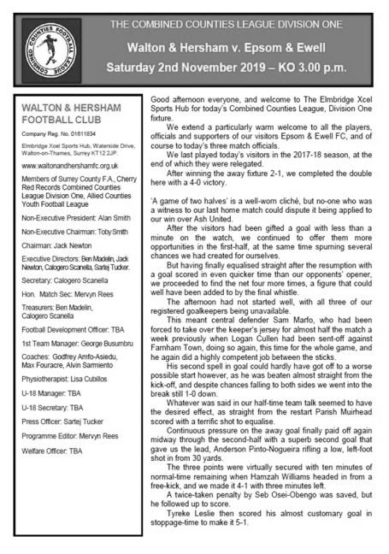
Outplayed at the Hub

Despite a fine performance from Marlon Pinder, making his second debut for the club and scoring one of our three goals while making the other two, our boys were well beaten at Walton on Saturday with only an injury time penalty from Bobby Bennett saving us from repeating the four goal defeat that happened on our previous visit in April of 2018.

Having just signed Jahmahl King in recent weeks, he lost his defensive partner Chaz-Lee Martin who will be out for a few weeks following a nasty facial injury that he received at Kensington & Ealing Borough seven days previously. His absence was huge as we completely subsided in seven mad minutes midway through the first half and despite fighting back to reduce the deficit to one by half time, we conceded another three goals in the second half on a very blustery day.

Our tactic of playing sideways across the park before hoofing the ball hopefully into the wind in the second half looked particularly agricultural, compared to the slick movement and passing of the opposition who quite rightly kept the ball on the deck as often as possible. It is almost as if we are relying on our strikers to do something special for us to score a goal instead of actually creating any chances. Fortunately in this case, Pinder came to the fore with an excellent individual display, as did Sean White in the first half against his old club, while some others were badly exposed at a level that I think many of them believe is beneath them.

We had our first major scare as early as the twelfth minute when a dangerous diagonal pass reached their striker and he rounded Ricardo Teixeira but just went a little wide in the process as Adam Heagney got back to intercept before being fouled and the danger was over. Four minutes later Scott Murphy played an equally clever pass to Toby Funnell, but the Swans keeper Ibrahim Ugradar was out to smother the chance very quickly. He wasn't quite so quick a minute later though as he raced out of his box and clattered Bennett who had rounded him. Because of the angle, there was little possibility of a red card but it was a stonewall yellow, which would have consequences for him later.

Just as it looked as though we were beginning to get a foothold in the match we conceded the opening goal in the 21st minute when a good ball in was lobbed over the advancing but exposed Ricardo from just inside the penalty area by Alvin Sarmiento. As has been the case so often frequently one goal became more as we conceded again four minutes later when King slipped while last man at the back, which enabled Sebastien Osei-Obengo to smash the ball unchallenged past Ricardo and then just three minutes after that when Heagney was beaten on their left wing,

some further interplay left Osei-Obengo with an easy finish in front of goal.

The game took an unexpected twist on the half hour when Pinder produced a mazy run at the Walton defence resulting in a low shot which Ugradar got a hand to but Rob Hendry was there first to knock in the loose ball, registering his fiftieth goal for the club in the process. Only 26 players in club history have reached this mark for us previously and whilst this one wasn't as memorable as some of his strikes, they all count. In the 37th minute the game was back on as a contest when Hendry produced a similar run to Pinder's. His shot was also saved but recovered by White who was a little wide, so he teed up Pinder for a close range finish with a clever pull back.

We had a major panic in our own area moments later as the home side regained control of the match, but the danger was cleared and moments later we could have made it 3-3 when White's interception was played into the path of Hendry, but with team mates waiting in the area, he struck at goal from an angle and sent the ball over the bar. We were then reminded of their threat in injury time when Ricardo made a good low save with his feet from a shot from an angle.

Regrettably the second half against the wind was a forgettable period. Possession was frequently given up and chances were few. Pinder found Funnell at the back post but his pull back was cleared and in the 56th minute, the right winger's first cross was blocked back to him whereupon he then deceived Kyle Carton to reach the touchline and his low ball in was turned in from close range by Tyreke Leslie.

Ricardo tipped a dangerous shot over before reacting quickly to keep a long range shot out at the foot of his post, but we always looked likely to concede again and in the 81st minute a long range curling effort from an angle caught everyone out and dropped into the far corner of the net to complete Osei-Obengo's hat trick. Worse was to follow as Heagney was injured but with all three substitutes used, he hobbled on. However, he could do nothing about the 89th minute crossfield ball that left Osei-Obengo in space and he casually drew Ricardo out before clinically striking the ball under him to register his fourth goal of the match.

There was just time for a penalty after Ugradar brought Pinder down, earning him a second yellow card and Bennett struck the ball past the substitute keeper in the 94th minute, but it was far too little and far too late to change anything other than his personal goal stats. As the final whistle went, it must have been aware to all Epsom supporters just how far adrift we are from the likely top four, having played two of them in recent weeks.

It has to be said at this stage of the season that our league position of thirteenth is very disappointing, as is the number of goals conceded and it is time to start analysing why that might be happening, although you really hope our Management team have already been addressing that question. There are a number of theories doing the rounds, from some of the players not doing their jobs, to the team's preparation and weakness against physical teams, particularly at the back, or whether the players are sufficiently motivated by the Management team, or even whether some of the players are fit enough! These are not my thoughts, they are just what I have personally heard or read in recent days. As we find ourselves drifting further away from the four promotion spots with tough away matches to come against Tooting Bec and Jersey next, more and more supporters will start to question what exactly is going on, as our supposed one year tenure at Step Six threatens to stretch into a third season. Immediate improvements are required from top to bottom at the club if we are not to miss out on promotion again.

Epsom and Ewell; Ricardo Teixeira, Adam Heagney, Kyle Carton, Sean White,
Todd Murphy, Jahmahl King, Bobby Bennett, Scott Murphy (c), Marlon Pinder,
Rob Hendry, Toby Funnell

Sub: Lloyd Connelly for T.Murphy (60), Joe Bonass-Ward for Carton (64),
Jake Robinson for White (66)

From behind the goal
Tooting Bec 2-1 Epsom & Ewell
Combined Counties League Division One - Tuesday 12th November 2019

Salts edged out in entertaining encounter

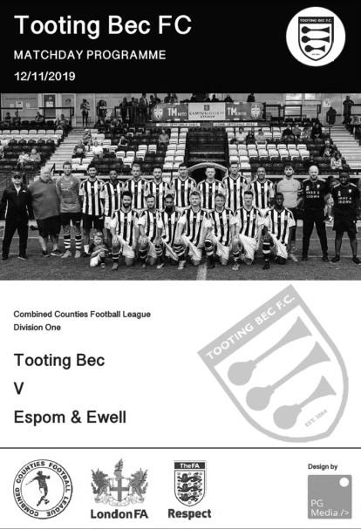
Although we may be strengthening as a squad right now, we have been a little unfortunate with the fixtures which have ensured four matches in a row against teams challenging for promotion, of which this was the third. As with our match at Kensington & Ealing Borough, I thought we were probably worth a draw, but an 85th minute winner gave the hosts all three points and left us in fifteenth place in the table, only four points above the relegation area.

We went onto the pitch at Tooting & Mitcham United's Imperial Fields ground with a strong enough looking line up. Chaz-Lee Martin reappeared at the back after damaging his eye socket a couple of weeks back while on the left James Fray, our new signing from Redhill, made his debut and he showed some potential, particularly in the first half. Only Adam Heagney from our arguably strongest eleven was absent, after picking up an injury away from football.

The opening half was quite even, although the hosts did get one really good opportunity following an awful back pass from Martin in the 12th minute which left the Bec striker through on goal with only Ricardo to beat. However, our keeper stood up well and was able to make a brave save, requiring treatment for a short while afterwards. The home side tried their luck with a couple of set pieces but neither were on target, while we were appearing a bit ineffective up front, giving away too many free kicks for offside. Bobby Bennett had a good battle with the excellent Carlo Fernando and our only real opportunity of the half came in the 43rd minute, when there was a major scramble in the hosts six yard box, during which three shots were registered on target, although all were blocked before the danger was cleared.

The half finished with a couple of scares, firstly with Jahmahl King being booked after taking one for the team as Tooting Bec broke away after the above scramble, and from the resultant free kick when an attacker met the ball at the far post, but Ricardo made a good reflex save to push the ball wide, with a header from the subsequent corner just

missing the frame of our goal.

As we attacked early in the second half a Rob Hendry corner was headed wide by Martin, but he was at a very narrow angle and most other players wouldn't even have reached it, while at the other end Ricardo was down well to save a low shot for a corner. We were just beginning to build up a bit of pressure though and Jake Robinson set up Bennett but his shot was blocked and from the corner Marlon Pinder couldn't get his low shot on target from 12 yards.

Unfortunately, we then went behind with the clock showing the 59th minute as a deep cross from out on the left was volleyed in at full stretch at the far post by Darius Heravi. It was a very good finish and we needed a quick response. Three minutes later we had one after an excellent move finished by Robinson who interchanged passes with Pinder before slotting the ball under the advancing keeper from eight yards to register his first goal for the club.

The game started to get a bit stretched from this point as both teams sensed victory. This led to a number of chances, mostly at the Bec end, firstly when a Hendry corner struck a defender and just went wide of his own post, before Bennett squared the ball to Hendry, who had the ball nipped off him by a defender at the last second as he prepared to strike. Then Scott Murphy was inches away from another corner. Substitute Taryn Smith also had a shot blocked after Hendry had set up Bennett and he had rounded the keeper, who almost brought him down in the process.

However, the home side were not without threat and Martin bundled their player over to earn our second yellow card of the match as he threatened to get through on goal. Still we pressed and Bennett struck over after a Murphy corner had been half cleared to him. Regrettably though we conceded disappointingly in the 85th minute when their striker got away on the right. His ball in was cleared but he was first to retrieve the loose ball and he set up substitute Liam Smith to finish from fairly close range with our defence all over the place.

This result ensured that we sit a long way away from the top four places and it doesn't get any easier as we make the journey to Jersey Bulls on Saturday with a local derby at Chessington and Hook United, weather permitting three days later. Did we deserve to lose? I don't think so, but chances missed here and at Kensington a couple of weeks back have really hurt us and we need to improve still further urgently.

Epsom and Ewell; Ricardo Teixeira, Lloyd Connelly, Joe Bonass-Ward, Jake Robinson, Chaz-Lee Martin, Jahmahl King, Bobby Bennett, Scott Murphy (c), Rob Hendry, Marlon Pinder, James Fray

Sub: Taryn Smith for Fray (71), Sean White for Robinson (87)

Centre page for results

Centre page for results

Dorking Wanderers – History
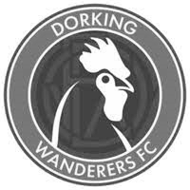
Football was first played in Dorking in the 1830s. The game was played in the street with the East and West of the town competing against each other in the annual Shrove Tuesday game.

The first senior club, called Dorking FC, was formed in1880 and became founder members of Surrey FA, while playing local rivals in the Surrey Senior League at West Bank, before moving to Fairfield Drive and on to Pixham Lane in the 1920s, and Pippbrook in the thirties.

Football in Dorking became quite literally central to the town in 1953, when a new stadium was built at Meadowbank - an iconic, picturesque location just behind the High Street. Among many memorable occasions in the Corinthian and Athenian Leagues, the stadium’s high point came in 1992 when a record-breaking crowd saw the latest version of Dorking FC take on Peter Shilton’s Plymouth Argyle in the first round proper of the FA Cup.

Unfortunately, there was to be no happy ending as, not only did the visitors secure a narrow 3-2 win, but Meadowbank never witnessed such heady days again. Two decades of under-investment and decline saw a dilapidated Meadowbank stadium, once the pride of Dorking, closed for health and safety reasons in 2013.

Meanwhile, Dorking Wanderers FC had been established in 1999. Founder members Marc White, Peter Buckland, Mark Lewington, Ian Davidson, Lee Spickett and Penny Gregg entered a fledgling team into the Crawley & District League, with home games played at Big Field in Brockham.

The club remained at its village location for eight years until, after several promotions it relocated to its current Westhumble home. This was a monumental project, which saw a huge off the field effort transform the once derelict site into a new, senior standard football ground.

The promotions kept coming and, in 2015, the club finished runners-up in the Sussex County League, securing promotion to the Ryman League.

A year later, despite finishing runners up in the Ryman Division One South, Dorking Wanderers were denied a second successive promotion in the play-offs. But it was a different story in 2016-17. Goal difference meant Dorking were runners up once again - despite matching the champions Tooting and Mitcham’s huge haul of 105 points - and this time promotion was won with play-off victories over Hastings and Corinthian Casuals.

These are truly boom times for Dorking football. The 2017-18 campaign saw the club line up for the first time in the Isthmian Premier League – matching the highest standard to date in the town’s long history at the time. And that has been followed by the return of local football to its ancestral seat at Meadowbank, with a multi-million pound stadium opening in July 2018, providing a new, state-of-the-art town centre home for Dorking Wanderers, and a base for future progress on and off the pitch. However, they then won that league and now compete at Step Two in the National League South.

The Dorking Wanderers Reserves have a firm commitment to develop local talent for the first team. They are the final piece of the club’s player pathway and ensure that the best local players have maximum opportunity to progress and represent their home town in the first team. The team compete in the Combined Counties League Division One under their management team of Carl Downs and Jordan Clark.

From behind the goal
Jersey Bulls 2-0 Epsom & Ewell
Combined Counties League Division One - Saturday 16th November 2019

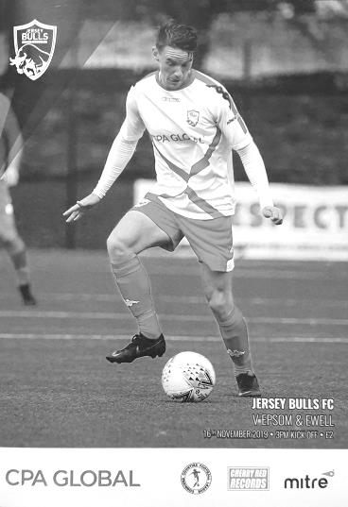
Jersey trip ends in narrow defeat

Back in May 2013, we made our first journey to the Channel Islands as guests of Guernsey. Six years on we visited the neighbouring island of Jersey, but the result was identical to the one we got back then, as a late goal in each half gave us a 2-0 defeat against a very solid Jersey Bulls team.

Jersey have conceded just five goals in fifteen league matches, so chances were always going to be at a premium, although hopes were raised slightly when we were made aware that a number of their regulars would be missing from this match on representative duty. However, as the morning dawned and the players met at Gatwick just after 6.30 a.m. on the morning of the match, it was apparent that we were missing a number of our own regulars, with Chaz-Lee Martin, Adam Heagney and Sean White injured, Jake Robinson ill and Marlon Pinder away.

Coming into the squad and making their debuts were Tariq Straker and George Smith, while returning to the club after a spell at Bedfont & Feltham was Steve Betancourt and he was joined by our returning traveller Conor Young who was back between the posts. All would see action on the artificial surface at the Springfield Stadium; an unusual venue with one enormous stand that housed everything from players facilities to a café, but with a giant green cage around the rest of the pitch, which may well prove to be an issue once they join the higher ranks as they surely will. Fortunately, with nearly a thousand seats available in the stand there would be room for everyone and 661 were present to see an understandably defensive set up from the Salts in the opening stages, with five men at the back and only Rob Hendry ploughing a lone furrow up front, despite suffering from a groin injury that would require his removal later in the match.

This tactic worked fairly well for a while as the hosts probed but rarely threatened. An early scare came in the third minute when a free kick was headed wide by an unmarked player before they hit the post in the tenth minute. The ball rebounded straight back into Young's arms, but the flag had gone up for offside by that point anyway, so wouldn't have counted as the player who was offside when the shot came in was in Young's line of vision. Smith made things difficult for himself in the 17th minute after he mistimed a tackle and picked up a yellow card in the process but there was little of real concern going on in our box as the centre backs of Todd Murphy, Jahmahl King and Lloyd Connelly mopped up any real danger.

On balance, it also has to be said that we created little to this point, largely due to our defensive formation which occasionally freed Bobby Bennett and Taryn Smith to support Hendry from either flank, but not as often as would normally be the case and James Fray, operating in central midfield, was the first to strike a shot in anger at the home goal, but it

missed the target.

As we approached the half, the home side exerted a bit more pressure, although Young still hadn't had a save of any difficulty to make until a right wing cross was blocked by the arm of Todd Murphy and a penalty was awarded. I'm informed that the ball was going straight at his face and he raised his hand in protection, but of course, that will always be seen by the officials as "hand to ball" and the Bulls Captain for the day Jay Giles scored the penalty in the 44th minute, although it wasn't the best strike and Young almost kept it out, almost diving past the ball before reaching back and half blocking the ball which then dribbled over the line almost apologetically.

It was unfortunate that we had not quite seen the half out, but we were nearly level four minutes into the second half, albeit in controversial circumstances when a dangerous ball in from Straker was met by Hendry ahead of the keeper, and he knocked the ball onto the bar and away. However, he had actually punched the ball onto the bar, but this was not spotted and it was clear that had the ball gone into the net it would have been given!

With the match still at just one-nil the game remained in the balance and the home side tried to extend the lead, breaking away from the Hendry crossbar incident and forcing Young into a good save. In the 53rd minute our keeper was involved again after a clearance fell kindly for Gabbiadini, but again the shot was turned around the near post with the resultant corner ending with a shot that was well over the bar from the same player.

Six minutes later Young did his best work as Baker broke through on goal, but our keeper stood up well as he has so often done in the past, and denied the striker with a good block. In response Smith and Straker struck at goal but both attempts were wide and in the 83rd minute Young saved well from Wilson.

We were beginning to threaten a little more as the game entered its closing stages though and King was not far over the bar with his long range effort while in the 89th minute Smith struck the post with a powerful effort from an angle. If this was unlucky then in the 92nd minute a dangerous ball in forced Connelly to get there ahead of a striker, but his touch beat Young and went into his own net for the second Bulls goal. This was particularly harsh as we were down to ten men at the time, following an injury to Straker that required his replacement by Sam Morgan, but the change only came after the goal and soon after this the final whistle blew.

Over the course of the ninety minutes the home side deserved the win. Young was far busier than their keeper and on another day, another couple of goals could have been scored, matching up with the Bulls average of four a game. In return though, it could also be argued that Smith's strike was ever so close to rescuing a point and that would have been quite an achievement. Still, performances like this are more encouraging than the recent ones at Kensington and Walton so it is hoped we can now push on and start climbing the table. With four promotion places on offer at the top of the table, no one wants to miss the flight, even though one of our players nearly did just that on Sunday morning. Last call for Taryn Smith!!

Epsom and Ewell; Conor Young, George Smith, Tariq Straker, Todd Murphy,
Lloyd Connelly, Jahmahl King, Bobby Bennett, Scott Murphy (c), Rob Hendry, James Fray, Taryn Smith

Sub: Steve Betancourt for Smith (61), Joe Bonass-Ward for Hendry (81),
Sam Morgan for Straker (93)

This Day in History – 23rd November
Date | Day | Competition |  | Opponents |  | Scorers
23/11/29 | Sat | London League | A | Erith & Belvedere | 1-2 | J.Parr
23/11/35 | Sat | London League | A | Bostall Heath | 3-4 | H.Pullen (2), J.Jones
23/11/46 | Sat | London League | A | London Telecoms | 2-1 | G.Brogdale (2)
23/11/57 | Sat | Amateur Cup 4q | A | Eastbourne | 2-3 | R.Colfar, J.Sorensen
23/11/63 | Sat | Athenian League 1 | H | Dorking | 0-4
23/11/68 | Sat | Surrey Senior Cup 3q | A | Merton Rushmere | 1-1+ | D.Legrice
23/11/85 | Sat | Isthmian League Premier Division | H | Yeovil Town | 2-2 | P.Kemp, D.Taylor
23/11/02 | Sat | Isthmian League 1s | A | Ashford Town (Middx) | 1-1 | J.Hall
23/11/13 | Sat | Combined Counties Premier Division | A | Molesey | 2-1 | M.Jarman, A.McGregor
Historical Decades
Date | Day | Competition |  | Opponents |  | Scorers
100 years ago – Epsom Juniors F.C.
22/11/19 | Sat | Surrey Junior League | H | British Red Cross | 2-0 | C.Aldridge, o.g.
90 years ago – Epsom Town F.C.
23/11/29 | Sat | London League | A | Erith & Belvedere | 1-2 | J.Parr
70 years ago – Epsom F.C.
26/11/49 | Sat | Corinthian League | A | Edgware Town | 3-6 | F.Marshall, R.Orford, T.Wright
60 years ago – Epsom F.C.
21/11/59 | Sat | Corinthian League | A | Dagenham | 0-2
50 years ago – Epsom & Ewell F.C.
22/11/69 | Sat | Athenian League  Cup 2 | H | Windsor & Eton | 1-2+ | K.Jolly
40 years ago – Epsom & Ewell F.C.
24/11/79 | Sat | Isthmian League 1 | H | Clapton | 3-0 | D.Burke, R.Lewis, C.Stewart
30 years ago – Epsom & Ewell F.C.
18/11/89 | Sat | Isthmian League 2s | A | Feltham | 3-0 | R.Kidd, P.Andrews, C.Walcott
20 years ago – Epsom & Ewell F.C.
20/11/99 | Sat | Isthmian League 3 | H | Great Wakering Rovers | 3-1 | T.Quinton, J.Holman, R.Sell
10 years ago – Epsom & Ewell F.C.
14/11/09 | Sat | F.A. Vase 2 | A | Moneyfields | 3-2 | M.Jarman (2), D.Marvell
History Corner – 23rd November
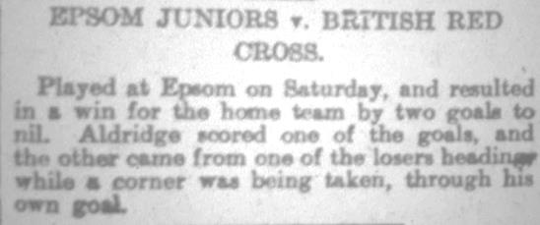
100 years ago this month we defeated British Red Cross by two goals to nil in the Surrey Junior League to register the first ever competitive win in our history. A goal from Charlie Aldridge was added to by an own goal as we climbed off the bottom of the table. Unfortunately, our opponents would fold later in the season and we would not win another match, leaving us at the foot in our first season. Better times were coming though with two Surrey Senior League titles and a London League win, not to mention various cups and a Surrey Senior Cup Final, all in the next ten years! (see report above)

34 years ago today we welcomed the famous Yeovil Town to West Street for a League match in the Isthmian League Premier Division. They were a very well-known side and had former professional midfielder Gerry Gow in their

ranks, along with a youngster by the name of John McGinlay who would go on to a fine career for Bolton Wanderers amongst others, not to mention Scotland.

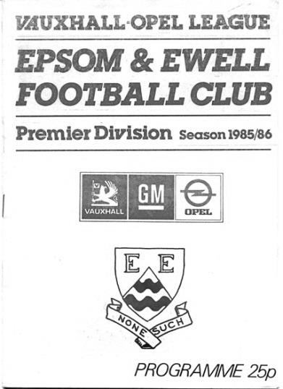
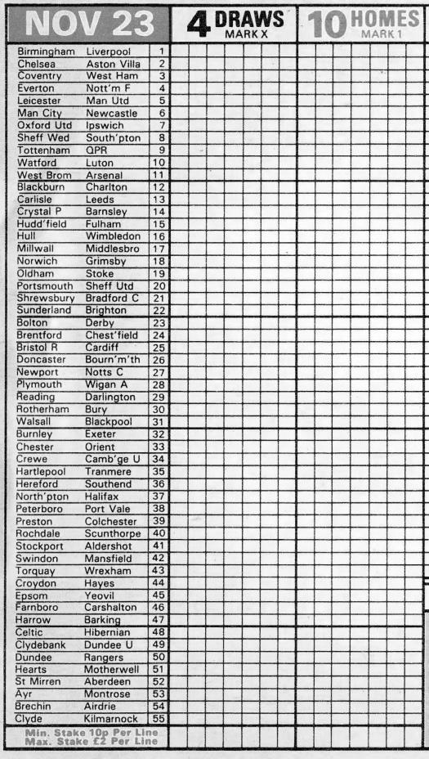
McGinlay scored the first goal for Yeovil Town, and although striker Peter Kemp equalised for us, we were trailing again as the game neared its final seconds before a low strike from defender Dave Taylor sneaked inside the post to earn us a 2-2 draw. Taylor is the father of a more recent defender, James.

It should also be said that this famous occasion was also memorable for another reason, as it was the first time our club ever appeared on the pools coupon! It was rumoured at the time that Taylor’s late equaliser had been the eighth draw on the coupon and that someone would have had the jackpot, although someone would have had to have selected us to get a draw against the non-league giants in the first place. Either way, they’ve probably spent it all now!

Player Sponsorship
Here is the latest list of players for 2019/20, with photos showing all of our boys and also our Management team that are available for sponsorship. Thanks as always to our Club Photographer Gemma Jarman.

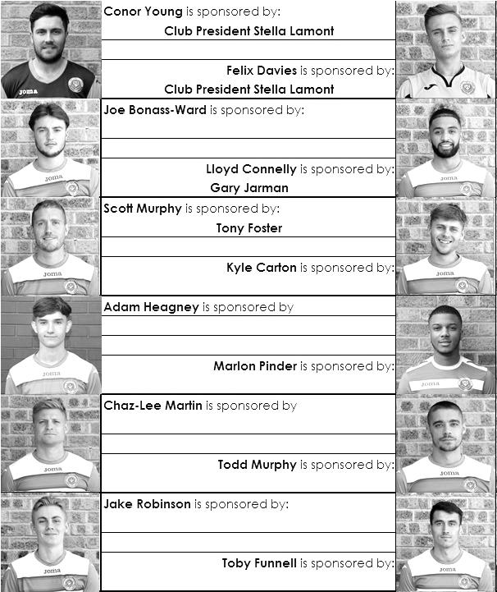

Sponsorship costs just £40 and it is easy to do. Just select a player who has not been previously sponsored and let a Committee Member know that you would like to sponsor them. Beware though. Until we have received the money it is possible for someone to jump in front of you, so don’t delay, sponsor today!

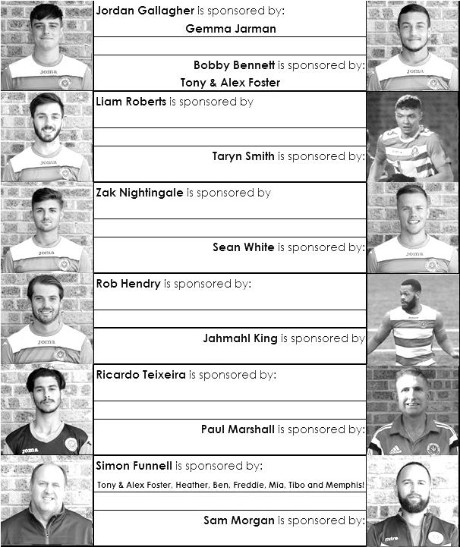

First Eleven Appearances - (max 17)
Name | Debut | 2019/20 |  |  |  | Career Totals
 |  | App | Sub | Tot | Goals | App | Sub | Tot | Goals
BENNETT Bobby | 12/08/2018 | 12 | 3 | 15 | 5 | 53 | 3 | 56 | 28
BETANCOURT Steve | 18/08/2018 | 0 | 1 | 1 | 0 | 21 | 2 | 23 | 1
BONASS-WARD Joe | 10/08/2019 | 11 | 2 | 13 | 0 | 11 | 2 | 13 | 0
CARNEY Billy* | 12/01/2019 | 1 | 2 | 3 | 2 | 13 | 7 | 20 | 8
CARTON Kyle | 03/08/2019 | 4 | 0 | 4 | 0 | 4 | 0 | 4 | 0
CHIN Louis* | 08/12/2018 | 6 | 1 | 7 | 0 | 19 | 2 | 21 | 0
CONNELLY Lloyd | 14/10/2017 | 15 | 1 | 16 | 2 | 93 | 5 | 98 | 8
DAVIES Felix* | 03/08/2019 | 11 | 0 | 11 | 0 | 11 | 0 | 11 | 0
FRAY James | 12/11/2019 | 2 | 0 | 2 | 0 | 2 | 0 | 2 | 0
FUNNELL Toby | 03/08/2019 | 13 | 1 | 14 | 1 | 13 | 1 | 14 | 1
GALLAGHER Jordan* | 07/08/2016 | 8 | 2 | 10 | 3 | 57 | 15 | 72 | 21
HEAGNEY Adam | 16/08/2016 | 11 | 0 | 11 | 1 | 125 | 13 | 138 | 4
HENDRY Rob | 08/08/2015 | 7 | 7 | 14 | 4 | 117 | 31 | 148 | 50
KING Jahmahl | 26/10/2019 | 4 | 0 | 4 | 0 | 4 | 0 | 4 | 0
LEWIS Rory | 03/08/2019 | 1 | 1 | 2 | 0 | 1 | 1 | 2 | 0
MARTIN Chaz-Lee | 03/08/2019 | 8 | 0 | 8 | 2 | 8 | 0 | 8 | 2
MORGAN Sam | 11/09/2018 | 0 | 1 | 1 | 0 | 3 | 10 | 13 | 0
MURPHY Scott | 20/01/2007 | 15 | 0 | 15 | 4 | 106 | 2 | 108 | 13
MURPHY Todd | 27/11/2018 | 8 | 0 | 8 | 0 | 11 | 9 | 20 | 0
NIGHTINGALE Zak | 03/08/2019 | 3 | 4 | 7 | 1 | 3 | 4 | 7 | 1
PINDER Marlon | 13/01/2018 | 2 | 0 | 2 | 1 | 15 | 1 | 16 | 3
ROBERTS Liam | 12/08/2017 | 3 | 8 | 11 | 2 | 53 | 29 | 82 | 19
ROBINSON Jake | 23/02/2019 | 13 | 2 | 15 | 1 | 22 | 3 | 25 | 1
SMITH George | 16/11/2019 | 1 | 0 | 1 | 0 | 1 | 0 | 1 | 0
SMITH Taryn | 28/10/2017 | 10 | 2 | 12 | 2 | 24 | 13 | 37 | 7
STRAKER Tariq | 16/11/2019 | 1 | 0 | 1 | 0 | 1 | 0 | 1 | 0
SULLIVAN Ryan* | 04/08/2018 | 1 | 0 | 1 | 0 | 31 | 2 | 33 | 0
TEIXEIRA Ricardo* | 19/10/2019 | 4 | 0 | 4 | 0 | 4 | 0 | 4 | 0
THOMPSON Ashley* | 21/08/2017 | 1 | 0 | 1 | 0 | 36 | 1 | 37 | 5
WHITE Sean | 02/08/2014 | 9 | 4 | 13 | 0 | 38 | 29 | 67 | 9
YOUNG Conor | 07/03/2015 | 2 | 0 | 2 | 0 | 63 | 0 | 63 | 0
* Player has left the club

CCL Division One Club Directory
AFC HAYES: Telephone: 0208 845 0110 - Colours: Blue and White Stripes/Blue/Blue
Ground: Farm Park, Kingshill Avenue, Hayes, Middx. UB4 8DD

ASH UNITED: Telephone: 01252 344264 - Colours: Green with Red Trim/Green/Green
Ground: Shawfields Stadium, Youngs Drive, Shawfields Road, Ash, Aldershot. GU12 6RE

BAGSHOT: Telephone: 01252 623804 - Colours: Yellow/Black/Black
Ground: Camberley Town FC – Krooner Park, Wilton Road, Camberley. GU15 2QW

BEDFONT & FELTHAM: Telephone: 0208-890 7264 - Colours: Yellow/Blue/Blue
Ground: The Orchard, Hatton Road, Bedfont. TW14 9QT

BRITISH AIRWAYS: Telephone: 0208-890 7264 - Colours: Sky Blue/Navy Blue/Navy Blue
Ground: Bedfont & Feltham FC - The Orchard, Hatton Road, Bedfont. TW14 9QT

CHESSINGTON & HOOK UNITED: Telephone: 01372-602263 Colours: All Blue
Ground: Chalky Lane, Chessington. KT9 2NF

COVE: Telephone: 01252 543615 Colours: Yellow/Black/Black
Ground: Oak Farm, Squirrel Lane, Cove GU14 8PB

DORKING WANDERERS RES Telephone: 01306 400151 - Colours: Red & White Stripes/ Blue/ Red
Ground: Meadowbank Stadium, Mill Lane, Dorking. RH4 1DX

EPSOM & EWELL Telephone: 01737-553250
Colours: Royal Blue & White Hoops/Royal Blue/Royal Blue
Ground: Chipstead FC, High Road, Chipstead. CR5 3SF

EVERSLEY & CALIFORNIA Telephone: 0118 973 2400 - Colours: - White & Royal Blue Hoops /Royal Blue/ Royal Blue - Ground: Fox Lane, off Reading Road, Eversley. RG27 0NS

FARNHAM TOWN Telephone: 01252 715305 - Colours: - Claret & Sky Blue /White/ Claret & Blue
Ground: Memorial Ground, Babbs Mead, West Street, Farnham. GU9 7DY

FC DEPORTIVO GALICIA Telephone: 0208 831 9067 - Colours: Royal Blue/Royal Blue/White
Ground: Bedfont Sports FC - Bedfont Sports Club, Hatton Road, Bedfont. TW14 9JR

FLEET SPURS Telephone: 01252 662810 - Colours: Dark Blue with Red Trim/Dark Blue/Dark Blue
Ground: Kennels Lane Farnborough. GU14 0ST

GODALMING TOWN Telephone: 01483 417520 - Colours: Yellow/Green/Yellow
Ground: Wey Court, Meadrow, Godalming. GU7 3JE

JERSEY BULLS Telephone: 01534 449615 - Colours: Red and White
Ground: Springfield Stadium, Janvrin Road, St Helier, Jersey. JE2 4LF

KENSINGTON & EALING BOROUGH Telephone: 01372 360151 - Colours: All Blue
Ground: Leatherhead FC – Fetcham Grove, Guildford Road, Leatherhead. KT22 9AS

SANDHURST TOWN Telephone: 01252 878768 - Colours: Red & Black Stripes/Black/Black
Ground: Bottom Meadow, Sandhurst Memorial Park, Yorktown Road, Sandhurst. GU47 9BJ

TOOTING BEC Telephone: tba - Colours: Black & White Stripes/White/White & Black
Ground: Tooting & Mitcham United FC - Imperial Fields, Bishopsford Road, Morden, Surrey SM4 6BF

WALTON & HERSHAM Telephone: 07969 068731 - Colours: All Red
Ground: Elmbridge Excel Sports Hub, Waterside Drive, Walton-on-Thames. KT12 2JP

WESTSIDE Telephone: 01372-602263 - Colours: Yellow/Blue/Blue
Ground: Chessington & Hook United - Chalky Lane, Chessington. KT9 2NF

Match and Ball Sponsorships – 2019/20
Opponent | Date | Match Sponsor | Ball Sponsor
Fleet Spurs | 03/08/19 | Club President - Stella Lamont
Godalming Town | 20/09/19 | Paul Merritt
Tooting Bec | 27/09/19 | EEFC Management Committee
Kennington (FA Vase) | 31/08/19 | Geoff Dyke – celebrating his 70th birthday
AFC Hayes | 21/09/19 | Alex McKay (senior)
Farnham Town | 28/09/19 | Philip Harris
FC Deportivo Galicia | 19/10/19
Dorking Wanderers Res | 23/11/19
Sandhurst Town | 26/11/19
Bedfont & Feltham | 14/12/19
Westside | 28/12/19
British Airways | 11/01/20
Kensington & Ealing Borough | 21/01/20
Cove | 25/01/20
Ash United | 08/02/20
Chessington & Hook United | 22/02/20
Eversley & California | 21/03/20
Walton & Hersham | 31/03/20 | Tony Foster
Bagshot | 04/04/20
Jersey Bulls | 13/04/20 | Club President - Stella Lamont
Match sponsorship costs just £60.00!

Sponsorship includes:

Admission, programmes and hospitality for three people.

A full page advert in the programme and mascot for the day (if required).

Also, you get to choose the player of the match, who will receive a prize

If you are interested, just speak to a Committee Member,
or drop me an email at: richard.c.lambert@gmail.com

Combined Counties League Division One
Opponents All-time Records
inc 16th November 2019 | P | W | D | L | F | A | PPG | GD | Best  Win | Worst  Loss
Westside | 1 | 1 | 0 | 0 | 3 | 1 | 3.00 | +2 | 3-1 | -
Bedfont & Feltham | 5 | 4 | 1 | 0 | 25 | 12 | 2.67 | +13 | 9-2 | -
Godalming Town | 7 | 6 | 0 | 1 | 20 | 11 | 2.57 | +9 | 5-1 | 0-3
Bagshot | 4 | 3 | 0 | 1 | 12 | 3 | 2.25 | +9 | 7-1 | 1-2
FC Deportivo Galicia | 4 | 3 | 0 | 1 | 10 | 4 | 2.25 | +7 | 3-0 | 0-2
Ash United | 22 | 12 | 4 | 6 | 52 | 33 | 1.82 | +19 | 6-0 | 0-3
Cove | 37 | 17 | 10 | 10 | 82 | 60 | 1.65 | +22 | 7-0 | 1-6
Chessington & Hook | 30 | 13 | 9 | 8 | 63 | 45 | 1.60 | +18 | 6-0 | 1-3
Walton & Hersham | 55 | 25 | 11 | 19 | 108 | 111 | 1.56 | -3 | 8-0 | 0-8
Farnham Town | 20 | 9 | 4 | 7 | 32 | 33 | 1.55 | -1 | 3-0 | 1-4
Dorking Wanderers Res | 2 | 1 | 0 | 1 | 6 | 5 | 1.50 | +1 | 3-0 | 3-5
British Airways | 2 | 1 | 0 | 1 | 5 | 5 | 1.50 | 0 | 3-2 | 2-3
Eversley & California | 2 | 1 | 0 | 1 | 2 | 2 | 1.50 | 0 | 1-0 | 1-2
Fleet Spurs | 3 | 1 | 1 | 1 | 7 | 8 | 1.33 | -1 | 3-2 | 3-5
Sandhurst Town | 17 | 7 | 0 | 10 | 29 | 31 | 1.24 | -2 | 4-0 | 1-3
Tooting Bec | 4 | 1 | 1 | 2 | 7 | 9 | 1.00 | -1 | 3-1 | 1-4
AFC Hayes  (inc Brook House) | 13 | 2 | 4 | 7 | 19 | 24 | 0.77 | -5 | 7-0 | 1-4
Kensington Borough | 3 | 0 | 1 | 2 | 3 | 9 | 0.33 | -6 | - | 1-5
Jersey Bulls | 1 | 0 | 0 | 1 | 0 | 2 | 0.00 | -2 | - | 0-2

Combined Counties League – Division One
Saturday, 23rd November 2019 - Kick-off 3.00 p.m.
Epsom and Ewell  (Royal Blue & White hoops) | V |  | Dorking Wanderers Reserves  (Red / White)
Squad | NUMBERS |  | Squad
Conor Young |  |  | Drew Churchwell
Steve Betancourt |  |  | Jake Downs
George Smith |  |  | Jakub Saczek
Reisse Griffin |  |  | Pascal Sedgwick
Adam Heagney |  |  | Rory Cunningham Flood
Lloyd Connelly |  |  | Ben Dyson
Jahmahl King |  |  | Javin Dougan
Chaz-Lee Martin |  |  | James Dickson
Joe Bonass-Ward |  |  | Luke Cunningham
Todd Murphy |  |  | George Membrillera
Kyle Carton |  |  | Dennis Asante
© Scott Murphy |  |  | Jamie Autorino
Sean White |  |  | Trae Cook Appiah
Jake Robinson |  |  | Andrew Demby
James Fray |  |  | Joseph Elbishlawi
Tariq Straker |  |  | Callum Hulford
Toby Funnell |  |  | Jack O’Connor
Marlon Pinder |  |  | Kieran Taylor
Bobby Bennett |  |  | Daniel Crunden Jones
Rob Hendry |  |  | Ronald Schoengut
Taryn Smith
Simon Funnell | MANAGER |  | Carl Downs
Sam Morgan / Paul Marshall | ASSISTANTS |  | Jordan Clark
Sam Morgan | COACHES
 | PHYSIO |  | Andrew Bushe
REFEREE: T.Aslam
ASSISTANTS: C.Angol. P.Crichlow

OUR NEXT VISITORS TO HIGH ROAD
Sandhurst Town
Combined Counties League – Division One
Tuesday, 26th November 2019 – Kick-off – 7.45 p.m.

